
Miss Samantha Curtis
Headteacher

Miss Sarah Brooks
Willow Class teacher office@callowend.dowmat.education
Building a foundation for love and learning 01905 830337
Summer termly overview

Dear Parents/Carers,

Please find below a summary of what we will be learning this term in Willow Class.

Our aims for this term:
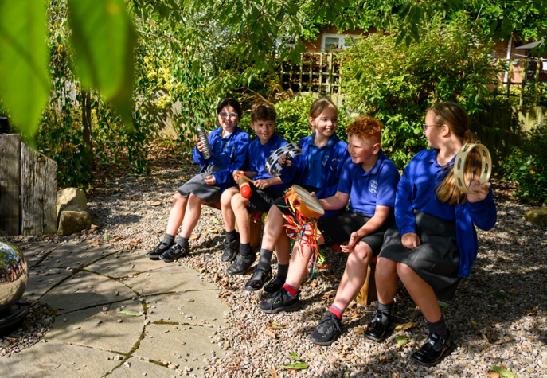
- To become fully independent, knowing when to ask for support.
- To apply maths skills with greater accuracy and efficiency, explaining reasoning clearly.
- To write in a more mature and controlled style (thinking about audience and purpose), independently editing and improving work to a high standard.
- To show strong resilience and determination, tackling challenges without giving up.
- To consistently produce work of a high standard in presentation across all subjects.
- To act as positive role models and leaders, supporting younger pupils and contributing to the school community.
- To demonstrate a responsible and proactive attitude to learning, preparing for the expectations of Year 6 / high school.
Here is what we will learn in each subject:
Writing | We will be reading Rose Blanche, focusing on creating effects on the reader and atmosphere in our writing. We will also think about different writing purposes and practise levels of formality.
Reading | We will read Clockwork, developing our comprehension and inference skills. We will read this book together.
Mathematics | We will begin with fractions, decimals and percentages then move onto ratio, algebra and shape. We will finish the year with position and direction, statistics and converting units.
Science | We will learn all about the properties and changes of materials and design our own experiments.
History | Answering the question, ‘What was the impact of WW2 on the people of Britain?’ we will look at sources and use our critical thinking skills.
Geography | We will answer the question: Where does our energy come from? To do this, we will look at the different types of renewable and non-renewable energy sources.
Music | In July, we will be performing our play. Our music lessons will be focused on learning how to sing these songs. We will develop our singing technique whilst looking at music notation through singing songs from WW2 too.
Art | We will develop our drawing techniques and explore street art to create our own pieces.
DT | We will work together to make our own bolognese sauces. We will learn about food hygiene and safety and develop our own recipes.
RE | We will explore the gospel, thinking about ‘What would Jesus do?’ and compare our knowledge of different faiths by thinking about how faith helps people when life gets hard. We will also go on a trip to the Mandir.
Computing | We will learn how to use google sheets and formula.
RSHE | Before half-term, we will learn about ‘being our best’, exploring how we can set our own goals and look after our mental health. After half-term, we will learn about growing and changing. Please look out for more information on this.
French | Mrs Widdrington will teach us French after half-term.
PE | With Miss Christopher on Tuesdays, we will learn the rules of outdoor games and develop our skills in them. On Fridays, we will do WW2 dancing and fitness.

Additional information
PE:
Children in Willow class will have PE on Tuesdays and Fridays. Please make sure that they come to school in their PE kit. Weather permitting, Tuesdays will be outdoor PE whilst Fridays will be indoor. If your child wears earrings, please make sure they know how to take them out. Studs may be worn but they will be taped over.

Water bottles:
Please make sure that your child brings a water bottle to school every day – especially on PE days.

Coats/hats:
Please make sure your child is dressed appropriately for the changes in the UK weather! Applying sun cream at home and popping a hat in their bag for those warmer days and also sending a rain coat just in case ensures that they are set for any weather.

Staffing:
Mrs Scanlon covers PPA in Willow every Wednesday afternoon.
Mrs Prior (TA) is in Monday – Thursday mornings and Tuesday afternoon. During this afternoon, she runs Nurture Group. If you think your child could benefit from this or if you would like specific support following a change in family life, please let us know.

Homework expectations:
Homework will always reset on Monday to be completed by the following Monday. Children should complete maths homework and three games on Spelling Shed. Spelling rules will be taught on Mondays with spelling tests taking place the following Monday morning.

Please continue to encourage daily reading and Times Table Rockstars at home.

Thank you for your support.
Miss Sarah Brooks

