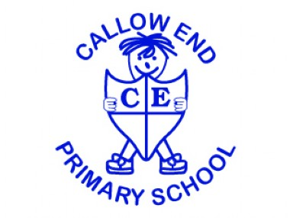
Miss Samantha Curtis
Headteacher

Mrs Scanlon and Mrs Widdrington
Oak Class teachers office@callowend.dowmat.education
Building a foundation for love and learning 01905 830337
Autumn termly overview

Dear Parents/Carers,

Please find below a summary of what we will be learning this term in Oak Class.

Our aims for this term:
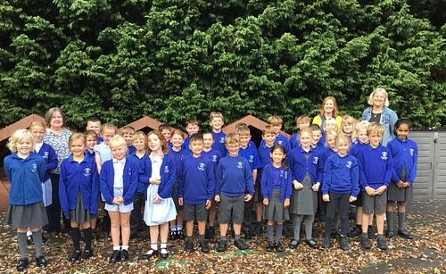
- To establish routines in the class.
- To take more ownership over organising equipment and resources.
- To read harder texts with fluency, and answer comprehension questions about those texts.
- To become more independent.
- To increase our fast recall of times table facts.
- To build writing stamina.
- To foster an enjoyment of learning!

Here is what we will learn in each subject:
Writing | We will be reading Little Red Reading Hood and Marshmallows, focusing on crafting descriptive sentences. We will then build up to writing our own character and setting descriptions, recounts and narratives.
Reading | Our class reader will be Stig of the Dump, which we will read in its entirety. Throughout the course of the term, we will also be busy reading: extracts from classic children’s fiction; poetry; non-fiction texts on prehistoric Britain and teeth; and extracts from books by Philip Reeves and Sarah Mcintyre. We will use this reading to develop our comprehension and inference skills.
Mathematics | In maths we will deepen our understanding of place value and how numbers relate to each other. We will then spend the rest of the term focussing on the four operations: addition, subtraction, division and multiplication. We will use these to help us problem solve.
Science | We will learn all about animals, including humans. We will be learning about skeletons, healthy eating, teeth and food webs.
History | We will be answering the question, ‘Would you prefer living in the Stone age, Bronze age or Iron age?’ we will Sequence events, look at sources and use our critical thinking skills.
Geography | Our topic is ‘Why do people live near volcanoes?’. We will learn how the earth is constructed, why and where we get volcanoes and the effects they have on the population around them.
Music | We will be learning about South African instrumental music with Miss Brooks.
Art | Following on from our history topic, we will be exploring prehistoric art, recreating the style of cave artists using charcoal and natural pigments.
DT | We will be thinking about where our food comes from and how we can eat seasonally. We will practise skills needed to prepare food as well as designing recipes using seasonal ingredients.
RE | We will be answering the question ‘What do Hindus believe God is like’? and then in the second half term we will focus on the question ‘What do Christians learn from the creation story?’
Computing | We will learn how computer systems and networks work, understanding how information is shared. We will continue to learn about online safety.
RSHE | Before half-term, we will learn about healthy relationships and listening to our feelings. After half-term, we will learn about recognising and respecting diversity by being tolerant.
French | French will be new to some children so we will start the year learning French words to get to know each other; introducing yourself, asking how someone is and how old they are. We will also be learning basic numbers.
PE | This term we will be doing hockey and fitness.

Additional information
PE:
Children in Oak class will have PE on Tuesdays and Wednesdays. Please make sure that they come to school in their PE kit. Weather permitting, Tuesdays will be outdoor PE whilst Wednesdays will mostly be indoors. If your child wears earrings, please make sure they know how to take them out. Studs may be worn but they will be taped over.

Water bottles:
Please make sure that your child brings a named water bottle to school every day – especially on PE days.

Coats/hats:
Please make sure your child is dressed appropriately for the changes in the UK weather! Applying sun cream at home and popping a hat in their bag for those warmer days and also sending a raincoat just in case ensures that they are set for any weather.

Staffing:
Mrs Widdrington teaches the class Monday, Tuesday and Wednesday afternoon. Mrs Scanlon teaches the class Wednesday morning, Thursday and Friday.
Mrs Powell (TA) is in every morning, and Mrs Gregory is in every morning and part of the afternoon.

Homework expectations:
Homework books will be sent home every Monday. Children will receive 10 spellings to practise. This can all be completed online on Edshed (Spelling Shed). The spelling games they play will just be based around the 10 spellings they have for that week, so the more they practise the more secure they will be for the spelling test the following Monday. They will be taught how to use these in school and logins/QR codes will be sent home. The new spelling rules will be taught on Mondays. Children will also receive some form of maths homework, normally compromising of some mental maths sheets.

Please continue to encourage daily reading and Times Table Rockstars at home.

Thank you for your support.

Mrs Scanlon and Mrs Widdrington

