RSHE parent information newsletter. Autumn 1 and 2 2025
Below are the details for RSHE lessons for Oak Class – Year 3 / 4
Me and My Relationships | Learning Outcomes – Children will be able to:
Human machines | 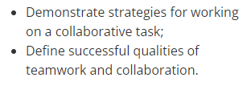
Ok or not ok? (part 1) | 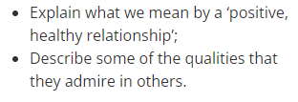
Ok or not ok? (part 2) | 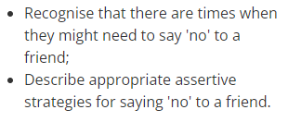
An email from Harold! | 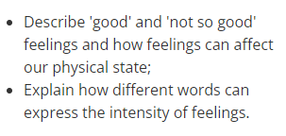
Different feelings | 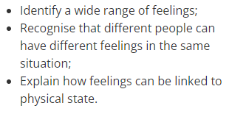
Under pressure | 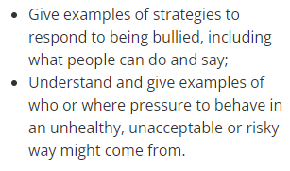

Valuing Difference | Learning Outcomes – Children will be able to:
Respect and challenge | 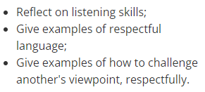
Family and friends | 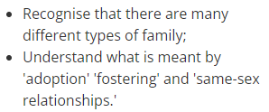
My community | 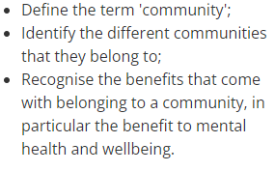
Our friends and neighbours | 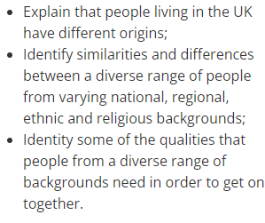
Let's celebrate our differences | 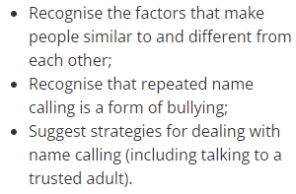
Zeb | 

