RSHE parent information newsletter. Spring 1 and 2 2026
Below are the details for RSHE lessons for Oak Class – Year 3/4
Keeping Myself Safe | Learning Outcomes – Children will be able to:
Danger, risk or hazard? | 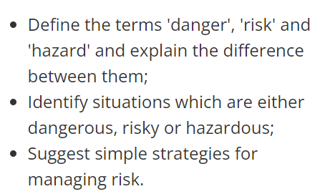
How dare you! | 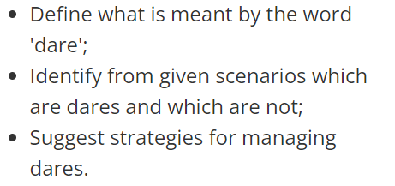
Keeping ourselves safe | 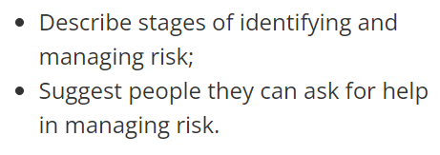
Raisin challenge | 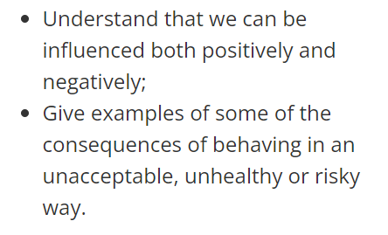
Picture wise | 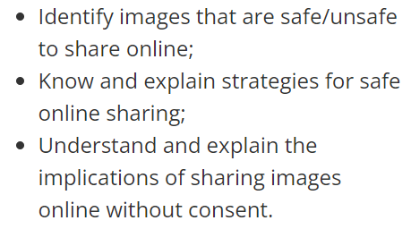
Medicines: check the label | 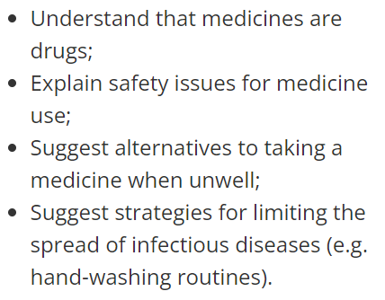
Rights and Respect | Learning Outcomes – Children will be able to:
Helping each other to stay safe | 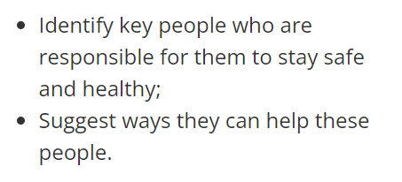
Recount task | 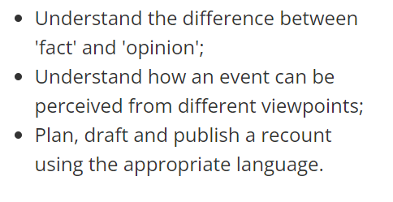
Our helpful volunteers | 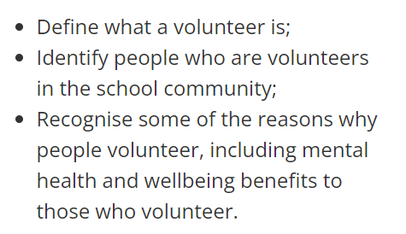
Can Harold afford it? | 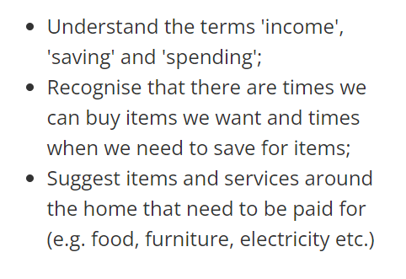
Earning money | 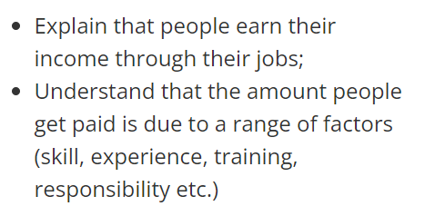
Harold’s environment project | 

