RSHE parent information newsletter Summer 1 and 2 2026
Below are the details for RSHE lessons for Oak Class – Year 3/4
Being my Best | Learning Outcomes – Children will be able to:
What makes me ME! | 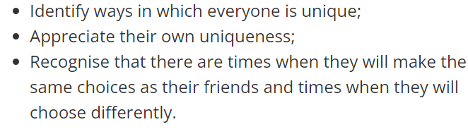
Making choices | 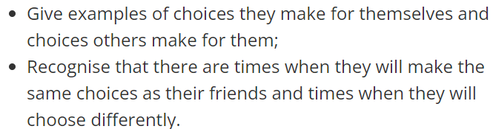
SCARF hotel | 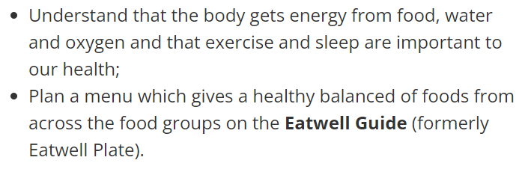
Harold’s Seven Rs | 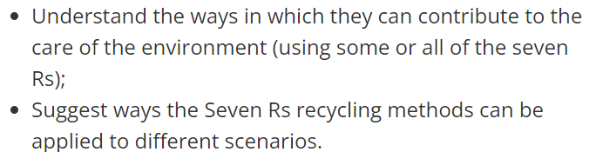
My school community | 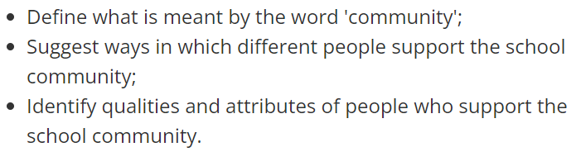
Basic first aid | - Know how to make a clear and efficient call to emergency services if necessary.  - Know some concepts of basic first-aid, like dealing with common injuries.

Growing and Changing | Learning Outcomes – Children will be able to:
Relationship tree | 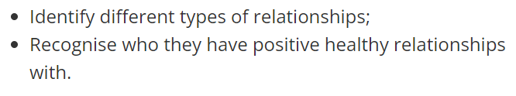
Body space | 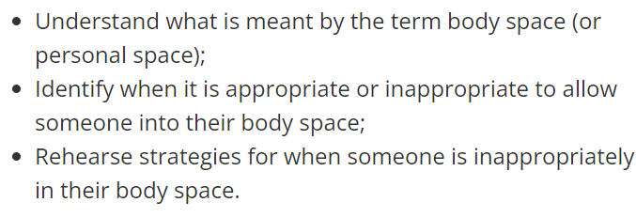
None of your business! | 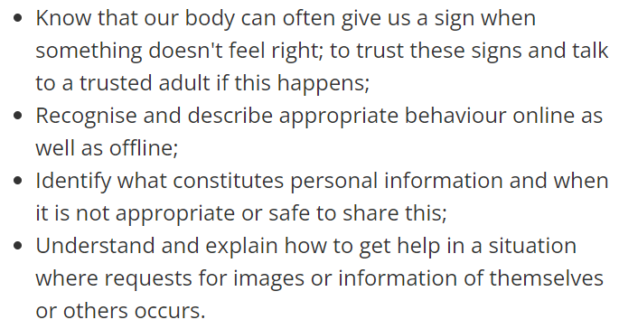
Secret or surprise? | 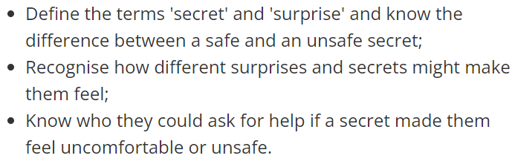
My changing body | 

