RSHE parent information newsletter: Autumn 1 and 2 2026
Below are the details for RSHE lessons for Oak Class – Year 3 / 4
Me and my relationships. | Learning Outcomes – Children will be able to:
Autumn 1 | Sept – Oct 2026
As a rule. | 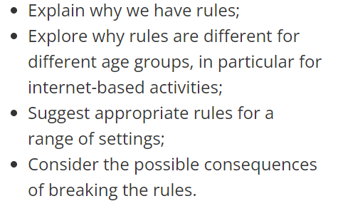
Looking after special people. | 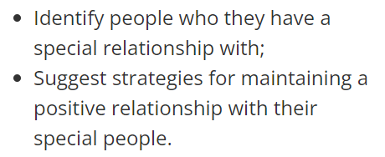
How can we solve this problem? | 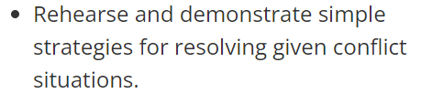
Friends are special. | 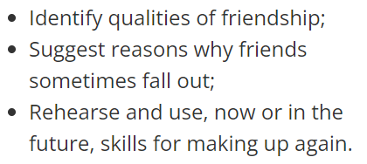
‘Thunks’ | 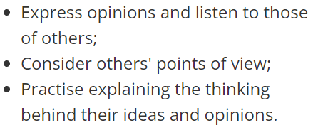
Dan’s dare. | 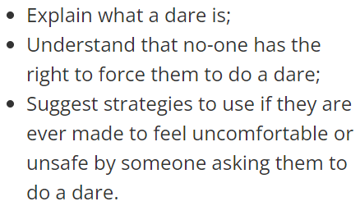

Valuing differences. | Learning Outcomes – Children will be able to:
Autumn 2 | Nov – Dec 2026
Can you sort it? | 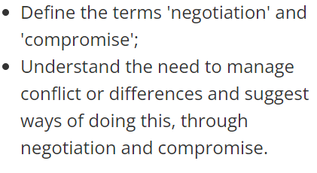
What would I do? | 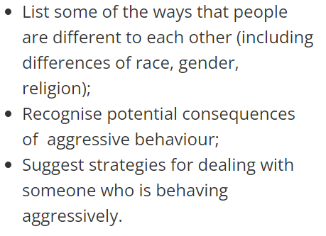
The people we share the world with. | 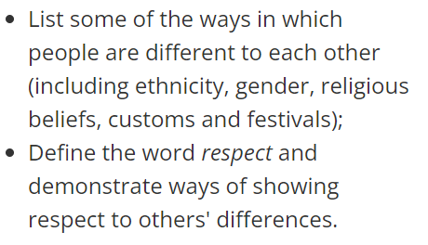
That is such a stereotype. | 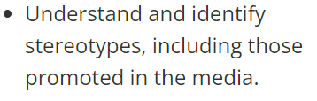
Friend or acquaintance? | 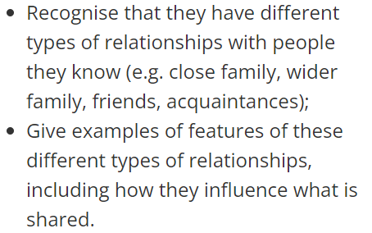
Islands. | 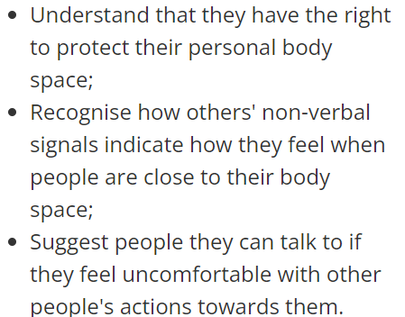

Mrs Scanlon & Mrs Widdrington

