
Miss Samantha Curtis
Headteacher

Miss Sarah Brooks
Willow Class teacher office@callowend.dowmat.education
Building a foundation for love and learning 01905 830337
Spring termly overview

Dear Parents/Carers,

Please find below a summary of what we will be learning this term in Willow Class.

Our aims for this term:
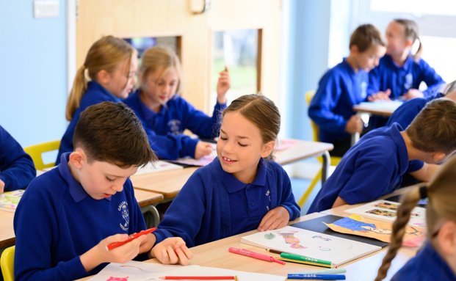
- To deepen our independence and ask for help at the right time.
- To apply number facts and calculation skills accurately in problem-solving and reasoning.
- To write with greater confidence, improving proofreading and editing skills.
- To develop resilience and perseverance when faced with challenges.
- To take pride in the presentation of work across all subjects.
- To continue being responsible role models around the school.
- To maintain a positive attitude to learning.

Here is what we will learn in each subject:
Writing | We will be reading Cosmic and Holes focusing on using dialogue effectively for characterisation and moving our narratives on. We will also think about different writing purposes and creating effects on the reader.
Reading | We will read Holes, developing our comprehension and inference skills. We will read this book together.
Mathematics | We will begin with revisiting written methods for multiplication and division. When we are secure, we will build on our fractions knowledge from last term to look at calculating using fractions.
Science | We will learn physics this term, beginning with forces and then learning all about space.
History | Answering the question, ‘What was life like during Tudor England?’ we will look at sources and use our critical thinking skills. We will go on a trip to The Tudor House Museum in Worcester to enrich our understanding of this topic.
Geography | We will answer the question: would you like to live in the desert? To do this, we will learn all about the Mojave desert.
Music | We will go to Young Voices at the start of term and have a chance to perform alongside others. After half term, we will learn about film music and compose our own soundtracks.
Art | We will develop our painting skills and explore using mixed media to see the different effects we can create.
DT | Applying our knowledge of mechanical systems, we will make our own pop-up books which we will test out on EYFS!
RE | We will explore the question of creation or science, examining different theories and whether they can complement each other. After this, we will learn about salvation and what Jesus did to save us.
Computing | We will program Micro:bits to work as data handlers and conduct our own experiments using them.
RSHE | Before half-term, we will learn about keeping safe. After half-term, we will learn about our rights and responsibilities.
French | Mrs Widdrington will teach us French after half-term.
PE | With Miss Christopher on Tuesdays, we will learn the rules of outdoor games and develop our skills in them. On Fridays, we will do gymnastics and Woodland School.

Additional information
PE:
Children in Willow class will have PE on Tuesdays and Fridays. Please make sure that they come to school in their PE kit. Weather permitting, Tuesdays will be outdoor PE whilst Fridays will be indoor. If your child wears earrings, please make sure they know how to take them out. Studs may be worn but they will be taped over.

Water bottles:
Please make sure that your child brings a water bottle to school every day – especially on PE days.

Coats/hats:
Please make sure your child is dressed appropriately for the changes in the UK weather! Applying sun cream at home and popping a hat in their bag for those warmer days and also sending a rain coat just in case ensures that they are set for any weather.

Staffing:
Mrs Scanlon covers PPA in Willow every Wednesday afternoon.
Mrs Prior (TA) is in Monday – Thursday mornings and Tuesday afternoon. During this afternoon, she runs Nurture Group. If you think your child could benefit from this or if you would like specific support following a change in family life, please let us know.

Homework expectations:
Homework will always reset on Monday to be completed by the following Monday. Children should complete maths homework and three games on Spelling Shed. Spelling rules will be taught on Mondays with spelling tests taking place the following Monday morning.

Please continue to encourage daily reading and Times Table Rockstars at home.

Thank you for your support.
Miss Sarah Brooks

